Project Report
On
Computer Networking: Concepts (CSE3751)


University Network Design and Implementation

Submitted by:

Name1:Monalisa Sahu Regd. No.:2341019274
Name2:Debneet Mohanty Regd. No.:2341013325
Name3:Arun Biswal Regd. No.:2341002223
Name4:Rohan Kumar Regd. No.:2341011233
B.Tech. CSIT 5th Semester (Section 23413B2)
INSTITUTE OF TECHNICAL EDUCATION AND RESEARCH
(FACULTY OF ENGINEERING)
SIKSHA ‘O’ ANUSANDHAN (DEEMED TO BE UNIVERSITY), BHUBANESWAR, ODISHA

i

Declaratio
Declaration

We, the undersigned students of B. Tech. of (CSIT) Department hereby declare that we own the full responsibility for the information, results etc. provided in this PROJECT titled “(University Network Design & Implementation)” submitted to Siksha ‘O’ Anusandhan (Deemed to be University), Bhubaneswar for the partial fulfillment of the subject Computer Networking: Concepts (CSE 3751). We have taken care in all respect to honor the intellectual property right and have acknowledged the contribution of others for using them in academic purpose and further declare that in case of any violation of intellectual property right or copyright we, as the candidate(s), will be fully responsible for the same.

Name1: Monalisa Sahu Regd. No.:2341019274

Name2:Debneet Mohanty Regd. No.:2341013325

Name3:Arun Biswal Regd. No.:2341002223

Name4:Rohan Kumar Regd. No.:2341011233

Date:

Place

Abstract
In modern educational institutions, efficient and secure communication between departments is critical for academic and administrative operations. This project focuses on the design and implementation of a scalable and secure university campus network using Cisco Packet Tracer. The network follows a three-tier hierarchical architecture consisting of core, distribution, and access layers. VLANs are implemented to logically separate departments such as CSE, ECE, Mechanical, Civil, Administration, Library, and Server Farm. Inter-VLAN routing is achieved using a multilayer core switch. Centralized services including DHCP, DNS, Web, FTP, and Mail servers are deployed to provide essential network services. OSPF is implemented as a dynamic routing protocol to ensure efficient route exchange, while NAT is configured to provide internet access. Security is enhanced through the use of Access Control Lists (ACLs) and Spanning Tree Protocol (STP). The project successfully demonstrates a real-world enterprise campus network design with reliability, scalability, and security.

Contents

Serial  No. | Chapter No. | Title of the Chapter | Page No.
1. | 1 | Introduction | 4
2. | 2 | Problem Statement | 5
3. | 3 | Methodology | 6-8
4. | 4 | Results and interpretation | 9-11
5. | 5 | Conclusion | 12
6. |  | References | 13

- Introduction

This project delivers a practical, lab-grade implementation of a university campus network that balances performance, security, and manageability. The design adopts a hierarchical three-tier architecture (access, distribution, core) to isolate departmental traffic with VLANs, centralize critical services in a dedicated server farm, and provide resilient, high-speed interconnects using EtherChannel and STP. Core routing is handled by a Layer-3 switch running OSPF for fast convergence and simplified route management, while an edge router provides NAT/PAT for controlled Internet access.
The implementation emphasizes operational realism: each department receives its own IP subnet and DHCP pool, servers are statically addressed and registered in DNS, and service access is constrained by purpose-built extended ACLs applied at the SVI level. Security and availability are treated as first-class requirements—ACLs limit lateral movement to administrative and server VLANs, STP and redundant links prevent outages, and OSPF ensures alternate paths for traffic.
Finally, the project includes a comprehensive verification plan so functionality and policy are demonstrable in Packet Tracer: connectivity tests (ping, traceroute), service checks (HTTP, FTP, Email, DNS resolution), ACL validation via hit counters and simulation, and resilience tests for link or device failures. The result is a repeatable, well-documented campus network suitable for teaching, assessment, and incremental expansion.

- Problem Statement

Design and implement a campus-scale university network in Cisco Packet Tracer that provides VLAN-based segmentation, inter-VLAN routing, centralized services, redundancy, and controlled Internet access.
Key objects to implement
- Devices: Access switches, distribution switches, Core MLS, edge router, servers, PCs.
- VLANs & addressing: VLANs for CSE/ECE/Admin/Library/Servers; one /24 per VLAN; SVIs on Core.
- Services: DHCP, DNS, Web, FTP, Email (servers in Server VLAN).
- Routing & NAT: OSPF for internal routing; NAT/PAT on edge router for Internet.
- Resilience: EtherChannel and STP between switches.
- Security: Extended ACLs on SVIs; IP helper addresses for DHCP.

- Methodology
Topology:- 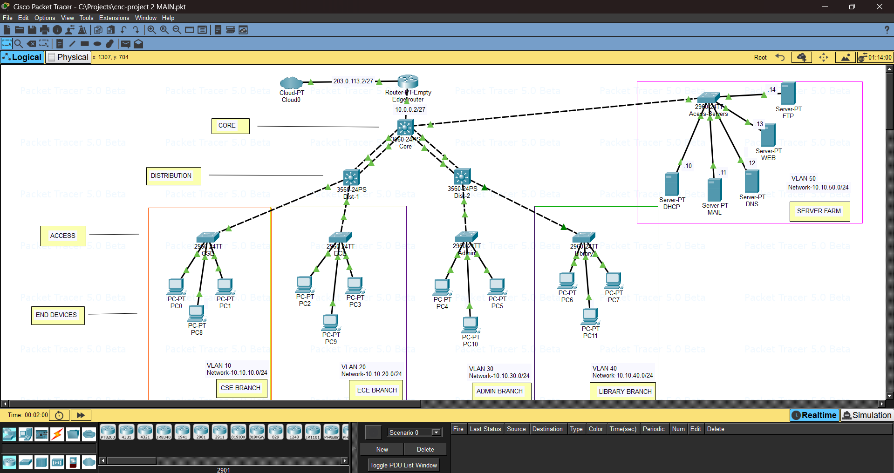
- Topology type: Three-tier hierarchical (Core → Distribution → Access). Purpose: scalability, fault isolation, and simplified policy enforcement.
- Edge connectivity: Cloud/edge router with public IP 203.0.113.2/27 and internal uplink 10.0.0.2/27 to the core.

Core
Key elements: Edge router connected to core 3560 switches.
Distribution
Devices: Two 3560 distribution switches labeled Dist-1 and Dist-2 connecting to branch access switches.
Access
- Branch switches and VLANs:
- CSE BRANCH: 2910 switch, VLAN 10 — 10.10.10.0/24 (PC0, PC1, PC8).
- ECE BRANCH: 2910 switch, VLAN 20 — 10.10.20.0/24 (PC2, PC3, PC9).
- ADMIN BRANCH: 2910 switch, VLAN 30 — 10.10.30.0/24 (PC4, PC5, PC10).
- LIBRARY BRANCH: 2910 switch, VLAN 40 — 10.10.40.0/24 (PC6, PC7, PC11).

Server Farm
- VLAN 50 — 10.10.50.0/24 hosts centralized services: DHCP(.10), MAIL(.13), DNS(.11), WEB (.12), FTP (.14). Servers connect to the core/distribution for high availability and simplified access control.

- This project’s CLI config brings up an edge router for Internet access, advertises the LAN via OSPF, and implements NAT/PAT so all VLANs (10/20/30/40/50) can reach the Internet. We also configured a layer-3 switch(core switch) for different VLANs & configuration of the layer-3 & layer-2 switch for the distribution and access layer respectively.

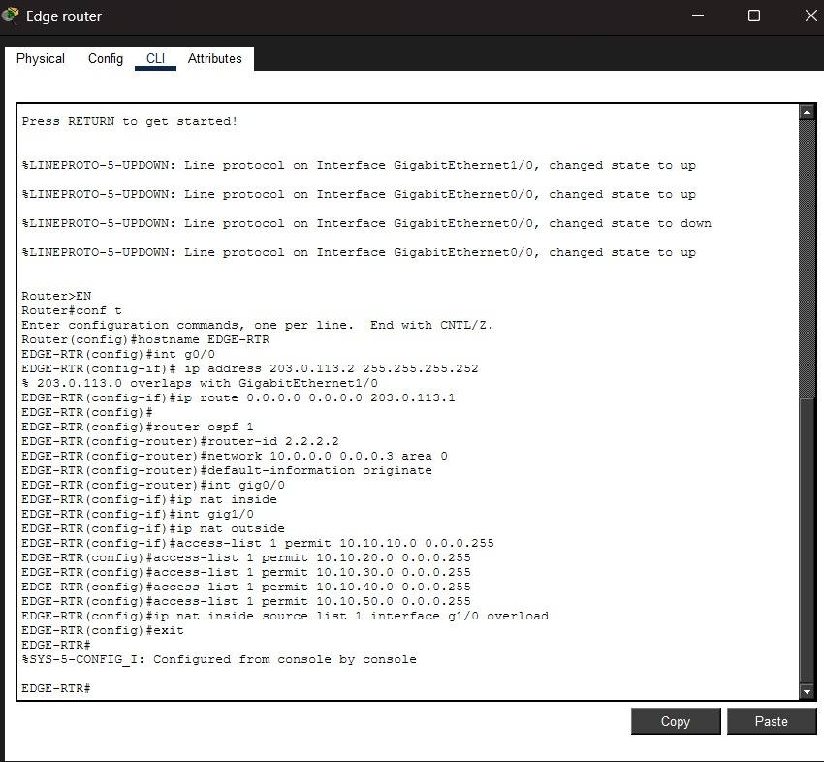

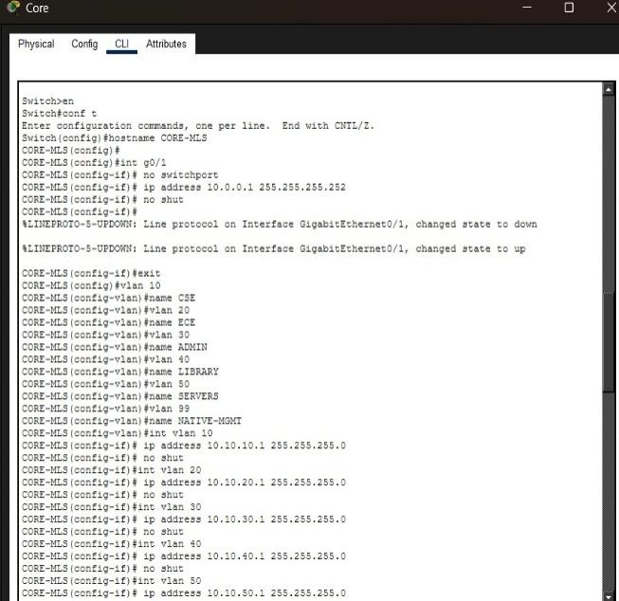
Fig:-router configuration
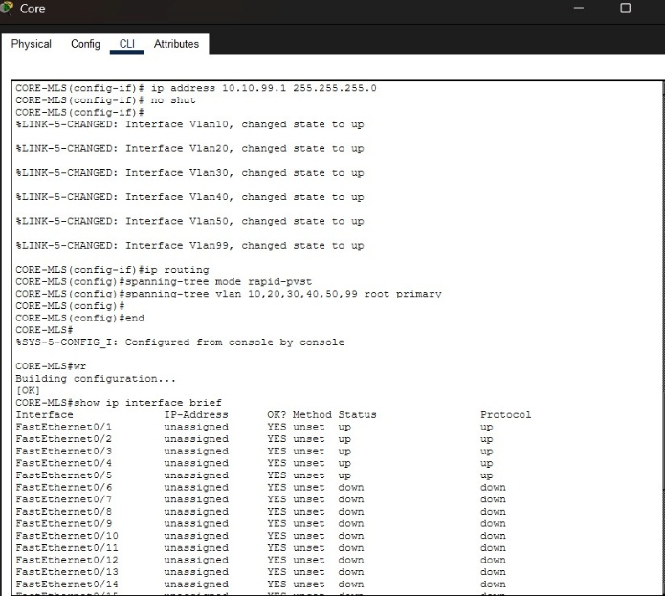

Fig:-valn config of core switch
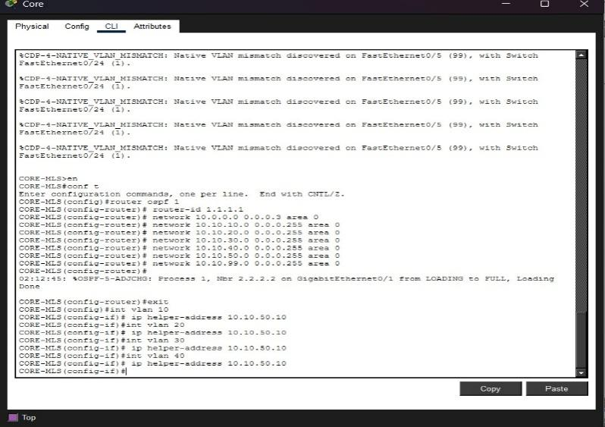

Fig:-OSPF and NAT configuration
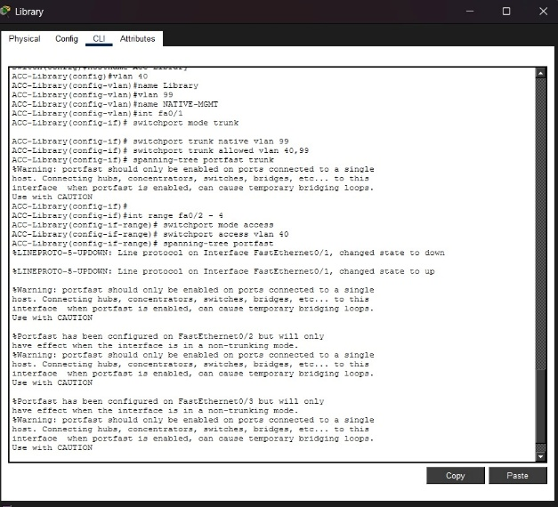
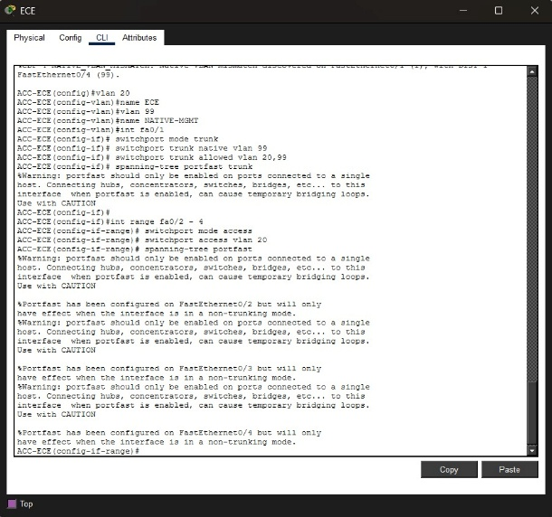
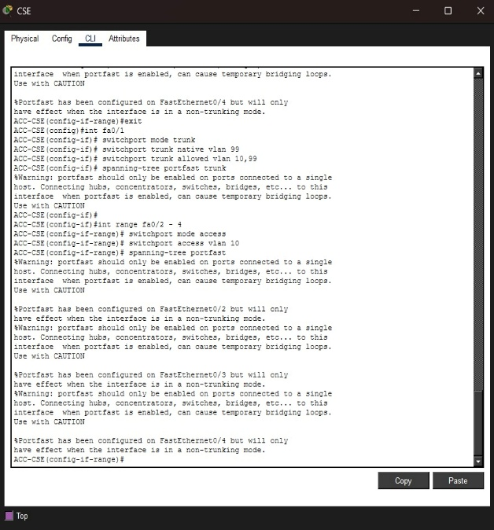
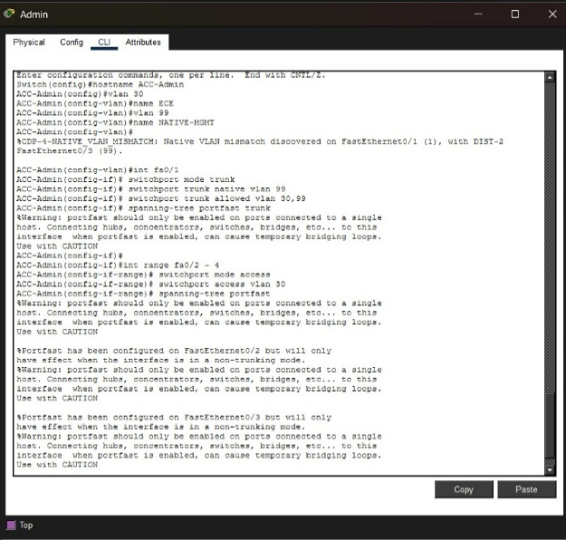

Fig:- Vlan configuration of switches for each department

VLANs 10–50 were created to segment departments and services.VLAN interfaces (SVIs)
configured on the core Layer-3 switch with IP addresses for inter-VLAN routing. SVIs
on the core switch enabled routing between VLANs.OSPF was configured on the core
switch and edge router.
Each VLAN subnet was advertised using network statements.The edge router was
configured
with ip nat inside and ip nat outside interfaces.
- Server Deployment:
  - DHCP server assigned IPs dynamically to all VLANs using ip helper-address.
  - DNS server resolved internal domain names.
  - Web, FTP, and Mail servers were configured with static IPs and tested using client PCs.
- Redundancy & Resilience:
  - STP was enabled on all switches to prevent loops.
  - EtherChannel was configured between core and distribution switches using channel-group and mode active.
- Security via ACLs:
- Extended ACLs were applied to SVIs to restrict access to Admin and Server VLANs.

4.Results & Interpretation
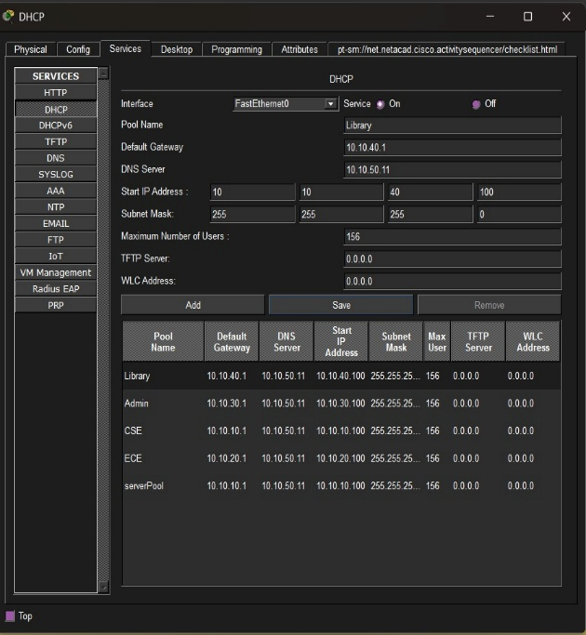
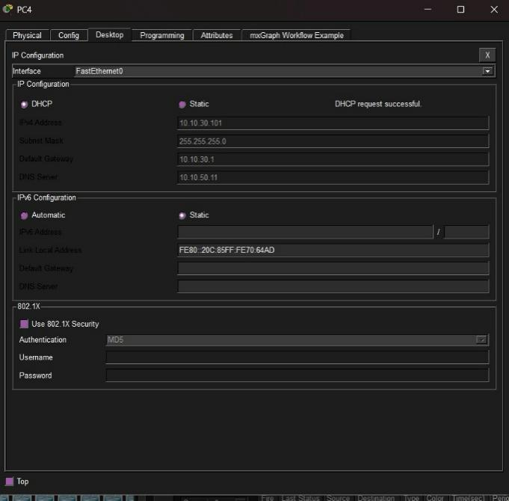

Fig:-DHCP server configuration and confirmation

To automate IP address assignment across VLANs, a centralized DHCP server was
deployed in the Server VLAN. The configuration ensures each department receives IPs from
its designated pool, along with gateway and DNS settings.DHCP service was enabled on the
server connected to VLAN 50 (Server VLAN). DHCP Pools Created Separate pools were
configured for each department and service zone.
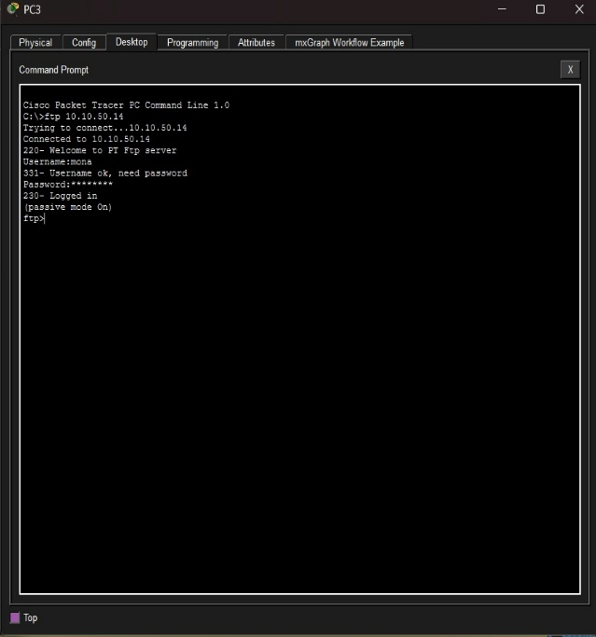
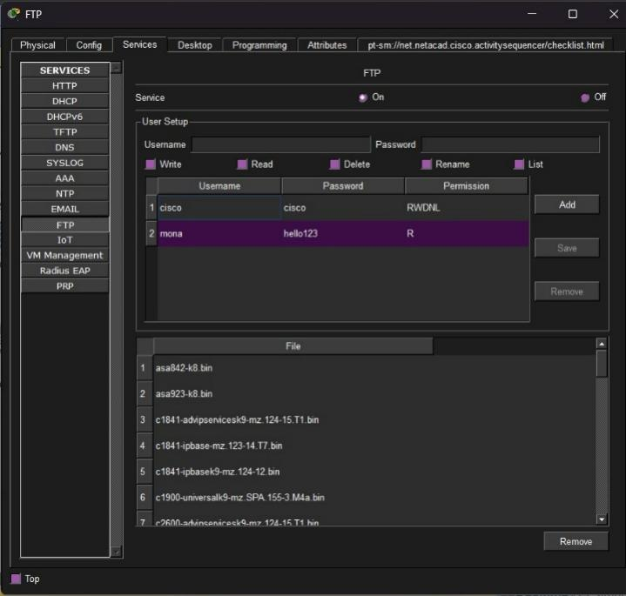

Fig:-FTP server configuration and confirmaton 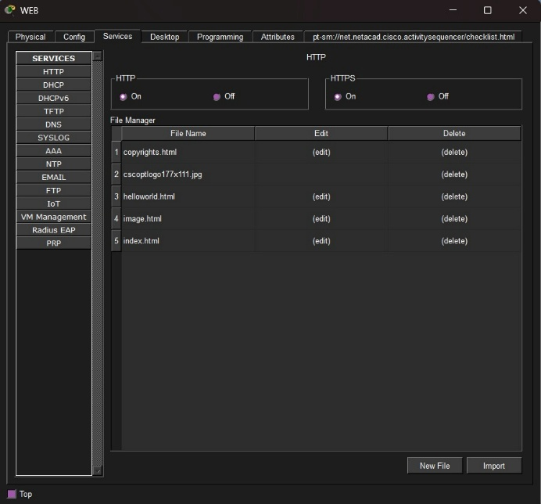 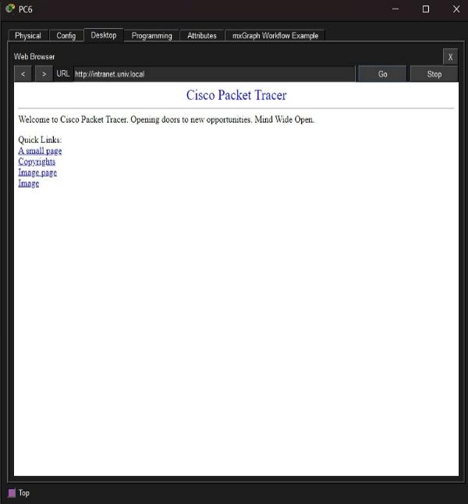
Fig:-WEB server configuration and confirmation

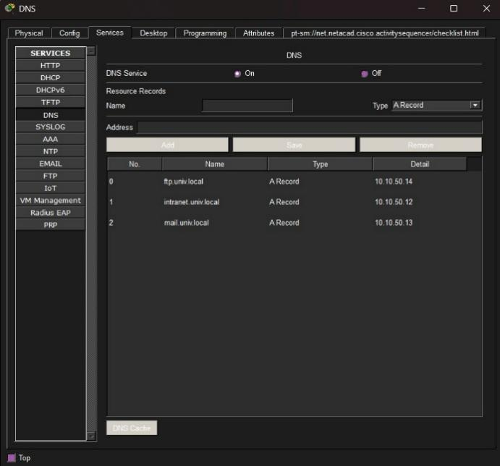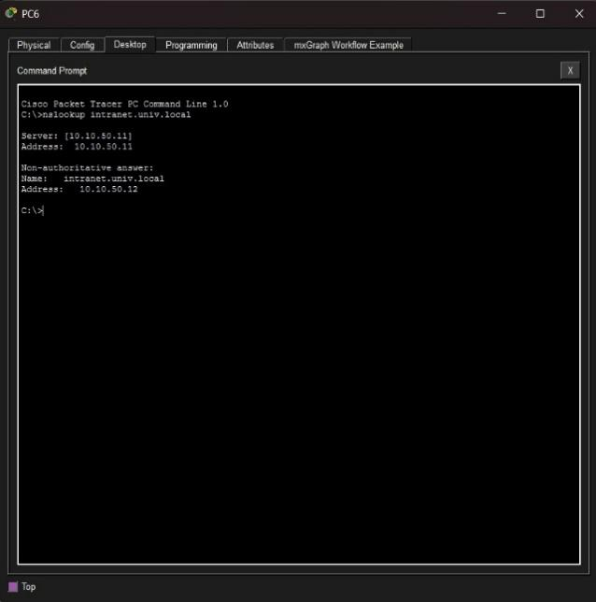
Fig:-DNS server configuration and confirmation

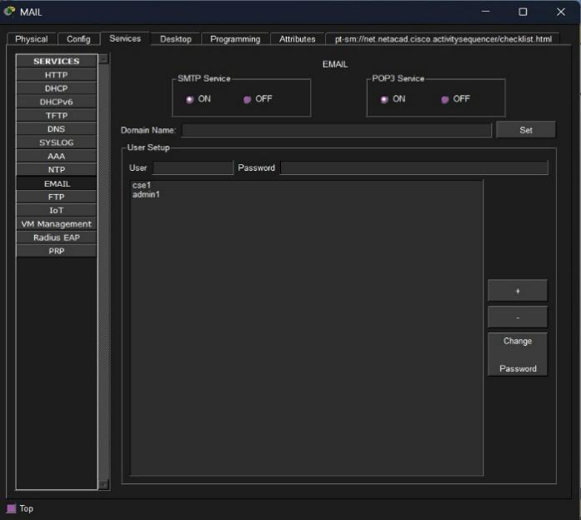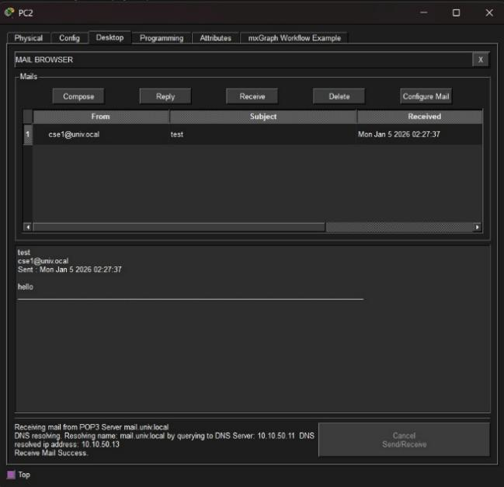
Fig:-MAIL server configuration and confirmation
The FTP server was configured with a static IP and enabled to allow file uploads and downloads across the campus network, verified using client PCs in different VLANs. The DNS server resolved internal domain names (e.g., univ.local) to IP addresses, facilitating access to web and mail services; its IP was distributed via DHCP. The Mail server supported SMTP for sending and POP3 for receiving emails, tested successfully between departmental PCs. The Web server hosted the university intranet site and responded to HTTP requests from all VLANs, confirming accessibility and proper routing. All servers were placed in a dedicated server VLAN and assigned static IPs, with ACLs ensuring restricted access from unauthorized segments.

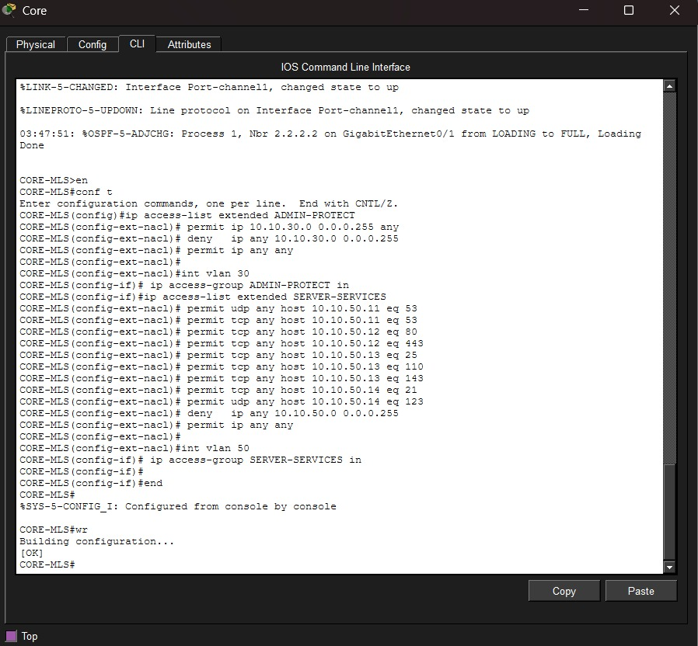
Fig:-CLI config of ACL on core switch

The Access Control Lists (ACLs) configured on the CORE-MLS switch enforce traffic restrictions and service-specific permissions across VLANs. The ADMIN-PROTECT extended ACL allows general access from VLAN 30 (CSE) to other networks but explicitly denies intra-VLAN traffic within 10.10.30.0/24, preventing lateral movement among CSE devices. This ACL is applied inbound on interface VLAN 30. The SERVER-SERVICES ACL permits specific protocols to reach designated servers in VLAN 50: DNS (UDP port 53), Web (TCP ports 80 and 443), Mail (TCP ports 25, 110, 143), FTP (TCP port 21), and NTP (TCP port 123). It also allows general IP traffic to the server subnet and includes a final permit ip any any to avoid unintended drops. This ACL is applied inbound on interface VLAN 50, ensuring only authorized service traffic reaches the server farm while maintaining accessibility for legitimate users
5.Conclusion
The University Network Design & Implementation project effectively achieves its objective of designing a robust, scalable, and secure campus-wide network that closely resembles a real-world university environment. Through this project, a comprehensive networking solution is developed to interconnect multiple academic departments, administrative units, and shared facilities while ensuring efficient communication and controlled access to resources. By adopting a hierarchical three-tier network architecture (core, distribution, and access layers), the network design ensures high performance, simplified management, and future scalability. The use of VLAN-based segmentation plays a crucial role in logically separating departments and server resources, thereby reducing broadcast traffic and enhancing overall network security. Inter-VLAN routing enables seamless communication between different departments while still maintaining proper isolation. The implementation of OSPF as the internal routing protocol allows dynamic and efficient routing across the campus backbone, ensuring reliability and adaptability as the network grows. Essential network services such as DHCP, DNS, Web, Email, and FTP servers are successfully deployed, supporting daily academic and administrative operations. Internet access is securely provided through an edge router using NAT/PAT, allowing authorized users to access external networks without exposing internal IP addresses. Network reliability and fault tolerance are strengthened through redundancy mechanisms like Spanning Tree Protocol (STP) and EtherChannel, minimizing downtime in case of link or device failures. Additionally, Access Control Lists (ACLs) are used to protect sensitive areas such as administration and server VLANs, ensuring that only authorized users can access critical resources. Overall, this project provides a strong practical foundation in enterprise and campus networking concepts. It helps learners understand how large-scale networks are designed, configured, secured, and tested in real-world scenarios. The successful completion of this project demonstrates the effective integration of networking protocols, services, security, and redundancy, making it highly relevant for academic learning and professional networking environments.

References

(as per the IEEE recommendations)

- CompTIA Network+ N10-008 Certification Guide by Glen D. Singh, 2nd Edition, Packt publication.
- Cisco Networking Academy, Introduction to Networks.
- Kurose, J. F., Ross, K. W., Computer Networking: A Top-Down Approach, Pearson
- Cisco Systems, "Configuring Inter-VLAN Routing," Cisco.com, 2023. [Online].

